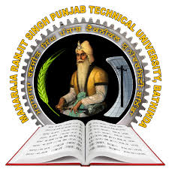
Maharaja Ranjit Singh Punjab Technical University
Badal Road, Bathinda -151001
(Established by Govt. of Punjab vide Punjab Act No. 5 of 2015)
wjkokik oDihs f;zx gzikp N?eBheb :{Bhtof;Nh, pkdb o'v, pfmzvk.

Inter-College Shooting Tournament (Men & Women) 2018-19
Detail Entry Performa
Name of Institute/College: …………………………………………………………….
Name of the Team Manager: …………………………………………………………..
Name of the Coach: ……………………………………………………………………
Men Section
10m Air Rifle | 10m Air Pistol
1. | 1.
2. | 2.
3. | 3.
4. | 4.

Women Section
10m Air Rifle | 10m Air Pistol
1. | 1.
2. | 2.
3. | 3.
4. | 4.
*It is certified that above mentioned shooters have their own weapons.

Signature of DPE/Sports Officer: …………………….

Date: …………… Signature of Principal/Director

